Computer Vision Home Work 2

vgramasw@andrew.cmu.edu

**Question 1.1 Gaussian Pyramid**

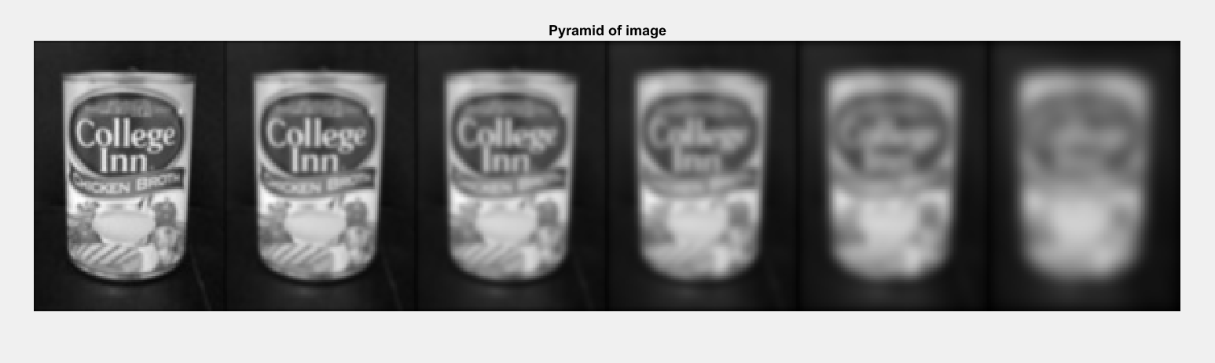

**Question 1.2 DOG Pyramid**

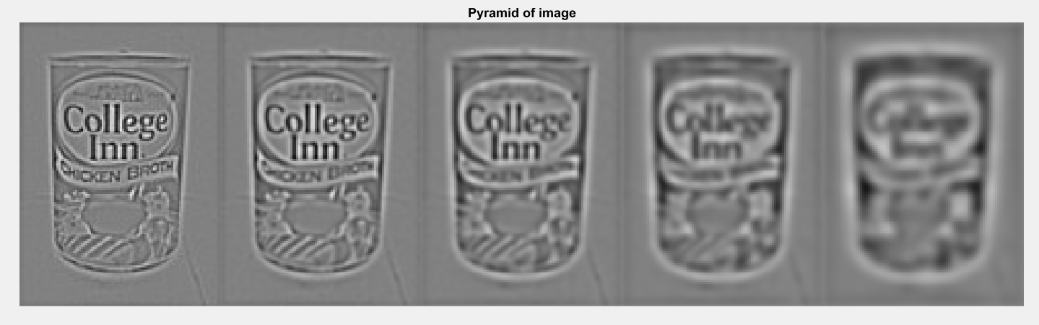

**Question 1.3 Edge Suppression**

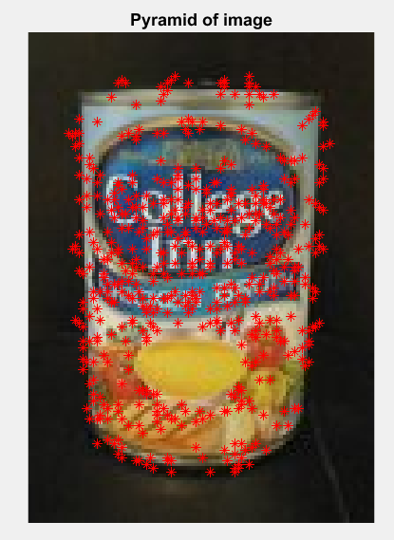 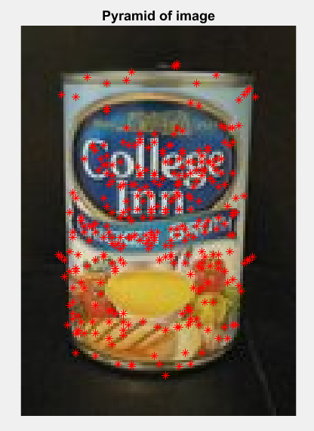

Without Edge Suppression With Edge Suppression

**Question 2.4 Descriptor Matching**

**Picture 1: Scanned Image with Pile**

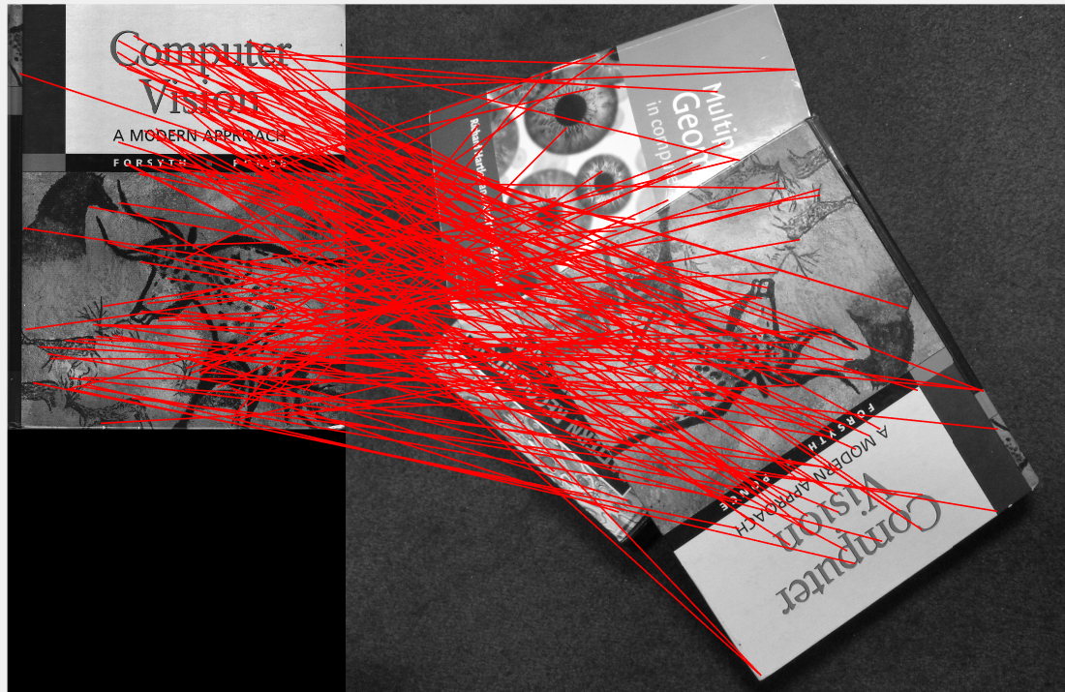

**Picture 2: Scanned Image with desk**

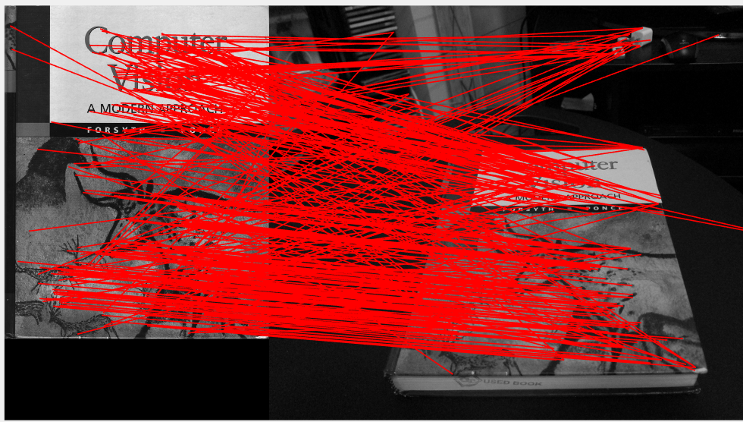

**Picture 3: Scanned Image with Floor_Rotated**

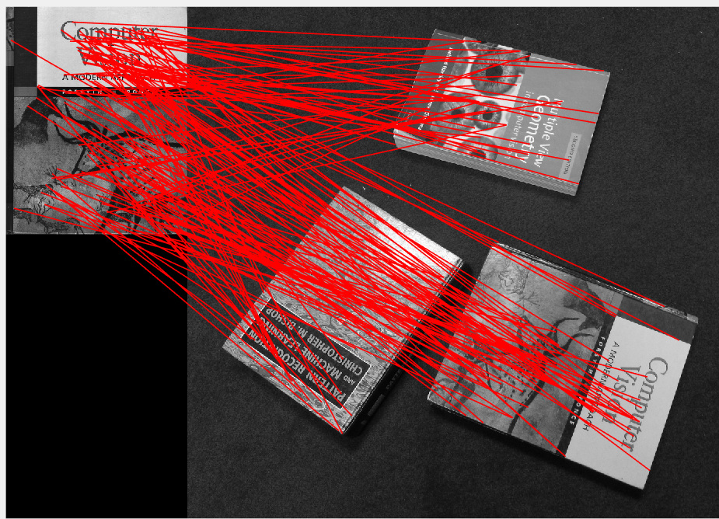

**Picture 4: Scanned Image with Floor**

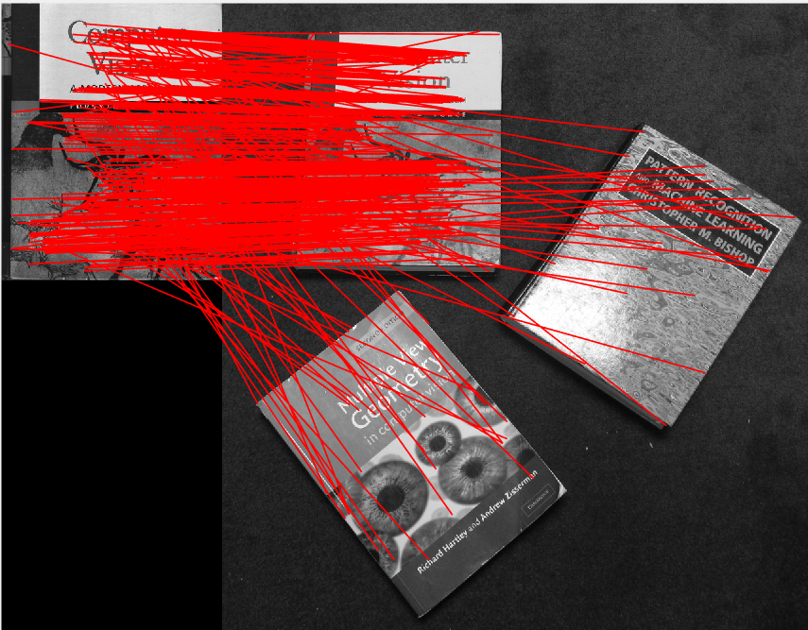

**Picture 5: Scanned Image with Stand**

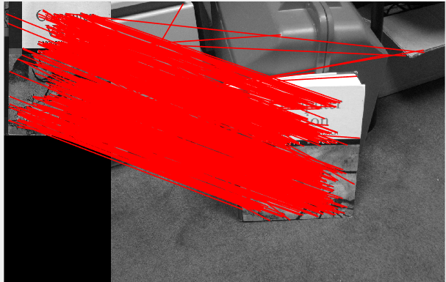

**Picture 6: Incline Images L and R with ratio value as 0.5**

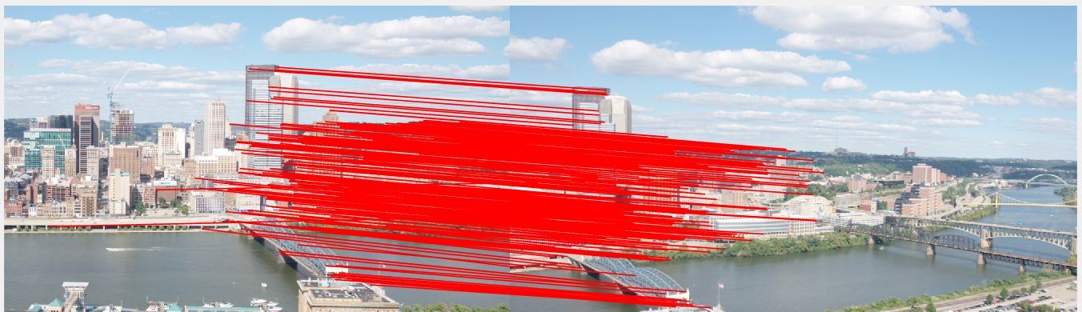

The best matches are achieved between the original scanned image and the image lying on the floor which is not rotated as shown in the **picture 4**.

The matches gets degraded when the original scanned image is matched with the rotated image lying on the pile as shown in **picture 1,** because while computing the BRIEF descriptors we take in the location and intensities of nearby pixels centered around a patch and this makes the BRIEF,rotation variant.

**Question 2.5 BRIEF and Rotations**

**Note: Since the it was taking a lot of time for computing for 360 rotations, I did it for 4 rotations.**

**Image Rotated by 0 deg** **Image Rotated by 10 deg**

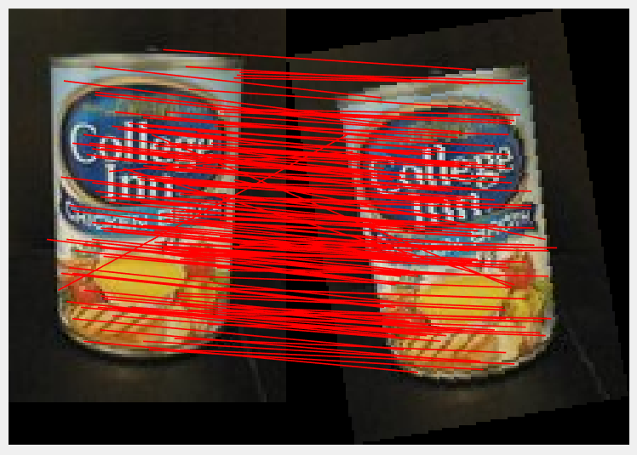 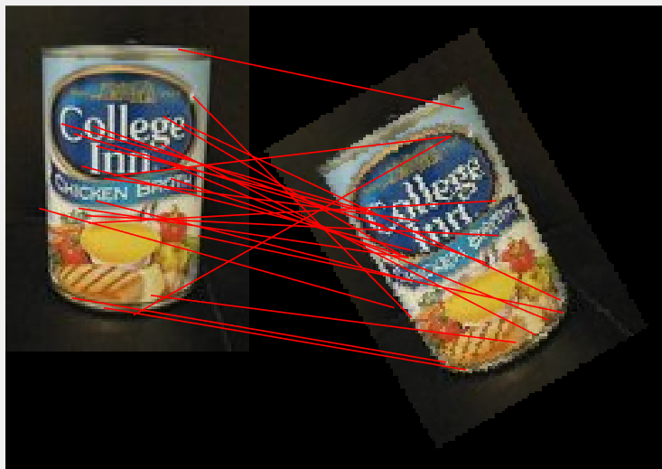

**Image Rotated by 20 deg Image Rotated by 30 deg**

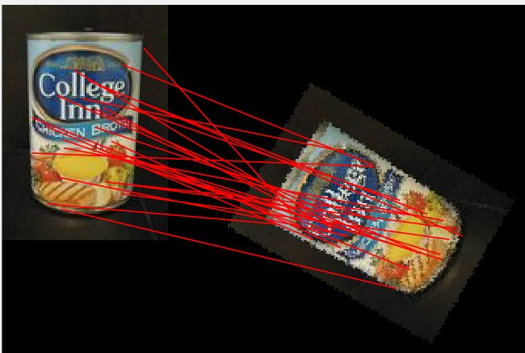 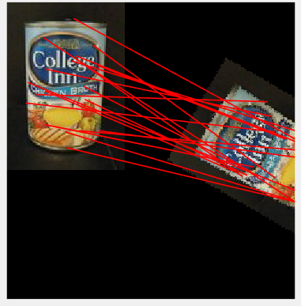

**Image Rotated by 40 deg**

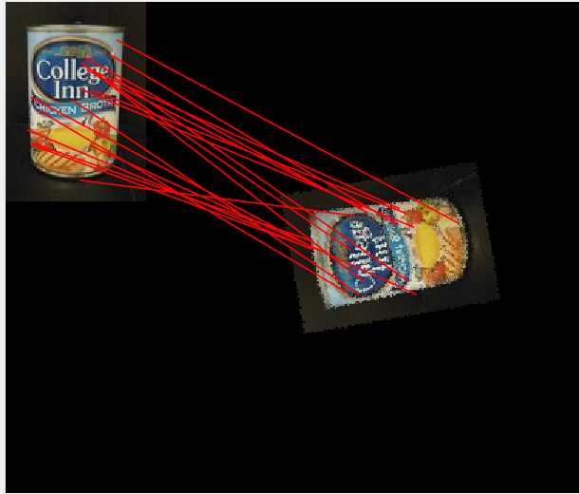

Bar Graph:

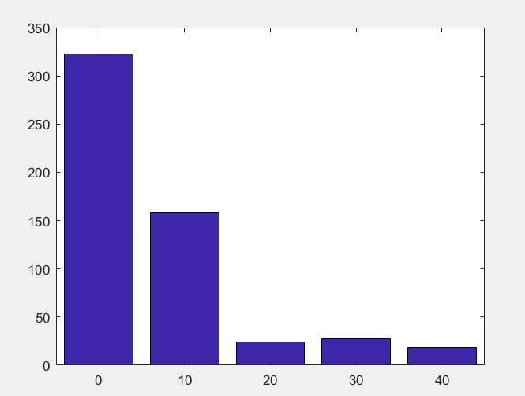

**Bar graph with angles in X direction and number of matches in Y direction**

The number of matches degrades drastically, as the images are rotated because the BRIEF uses the intensities of the nearby pixels centered around a patch to generate descriptors. When the image is rotated, the intensities of the pixels are no longer a match with respect to the patch and thus the matches reduces.

**Question 3.0 Planar Homography**

**a)**

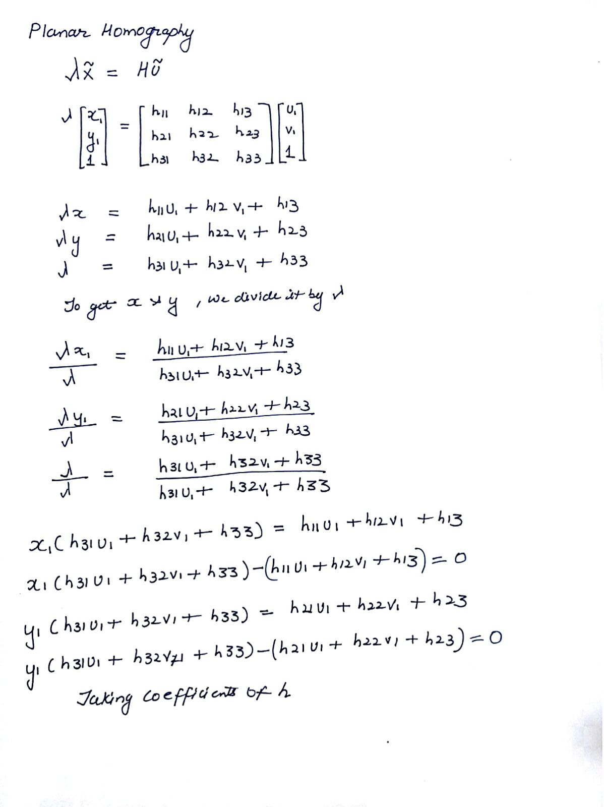

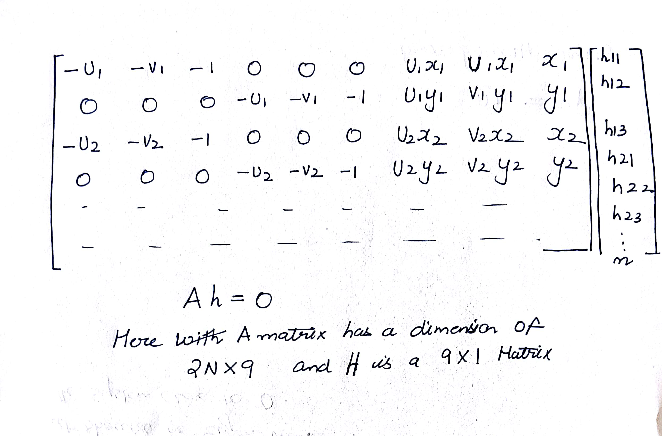

**b)** There are in total 9 elements in h. But the degree of freedom is only 8, as the elements of **H matrix** are independent of the scale factor and thus reduces the DOF from 9 to 8.

**c)** Each new correspondence gives two independent equations(information’s). We need 4 pair of points, with 8 independent equations for planar homography.

**d)**

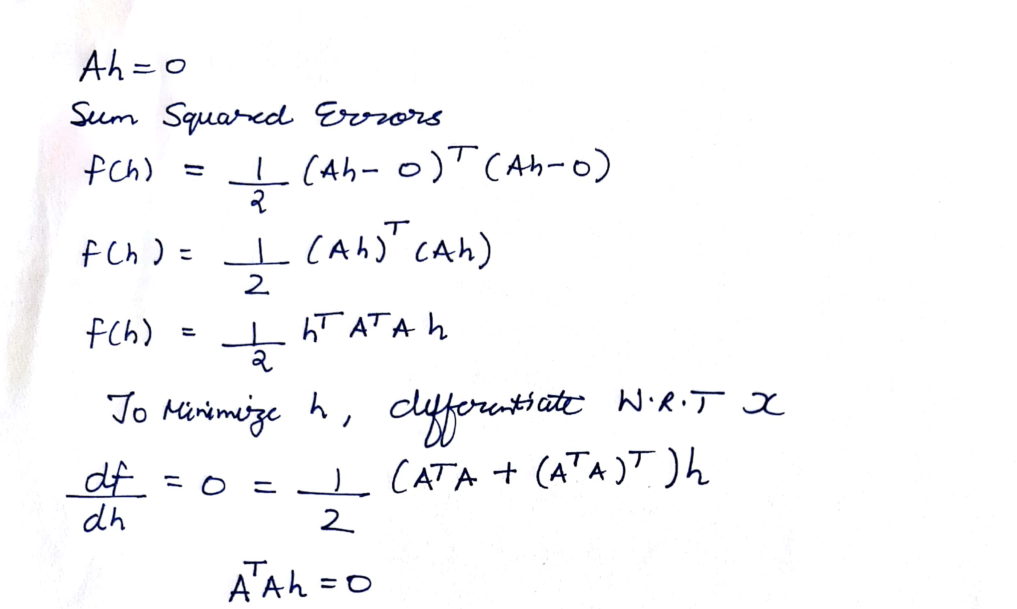

Steps followed are:

1. Derive 2N independent equations in the form Ah=0. Here we are using 4 pair of correspondences.
2. The resulting A matrix would be of size 8*9. In order to perform SVD , we make the A matrix square by multiplying it by **A’**.
3. Then we perform SVD.
4. The last column of V gives us the eigenvector corresponding to the least eigen value, which minimizes the system close to zero.
5. In ideal case **h** should be the eigenvector corresponding to zero eigenvalue, but in reality we only find eigenvalue which minimizes system close to zero.

**Question 6.1 Image Stitching**

**Warping:**



**Blending:**

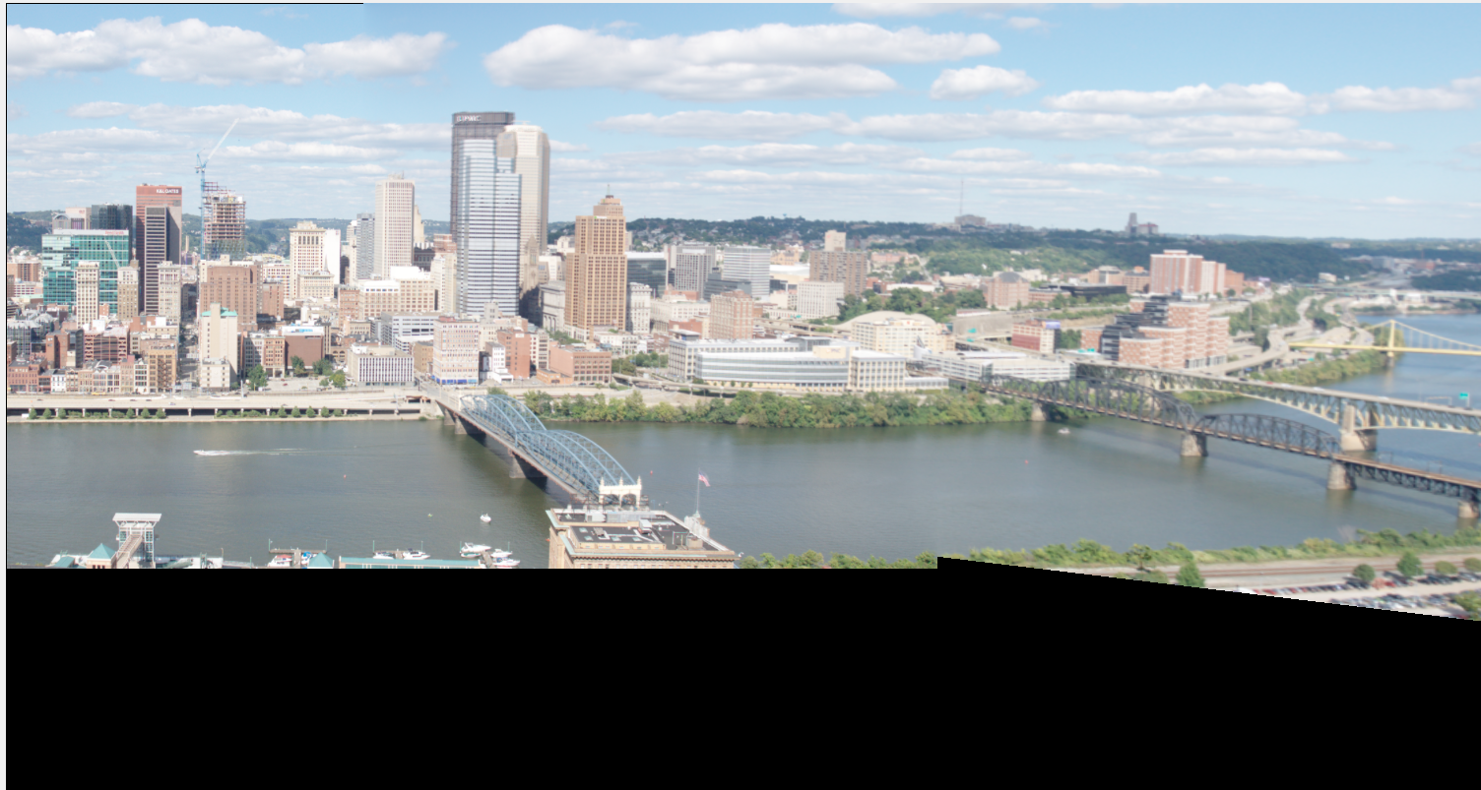

**Question 6.2 Image Stitching with no clipping with Compute H**

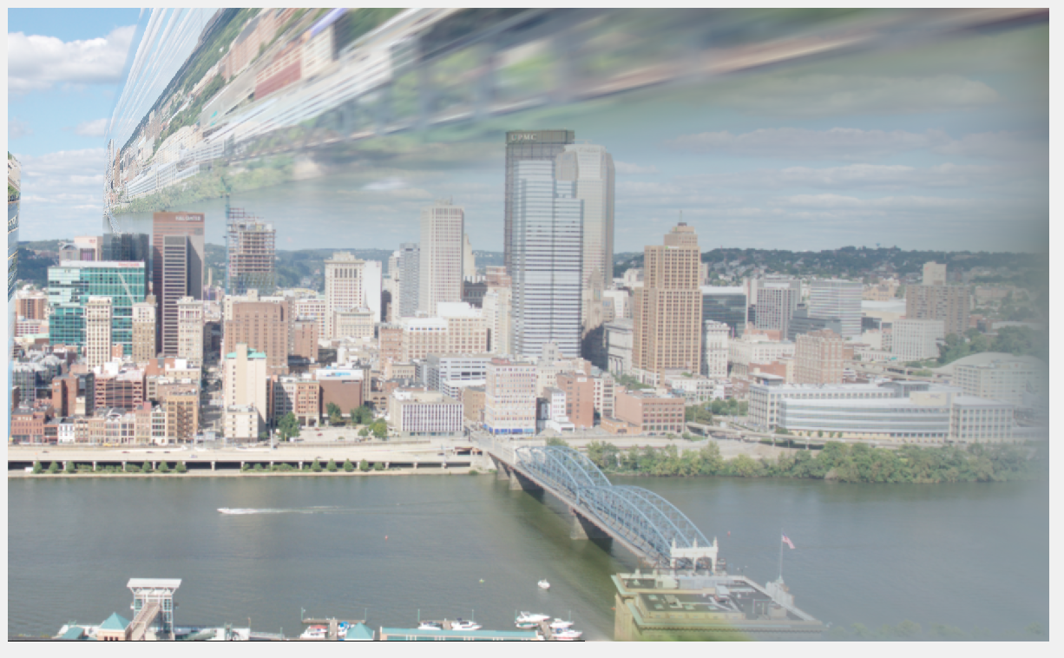

**Question 6.3 Final Panorama with Ransac:**

